Chemistry: Top Tips for Success at A Level

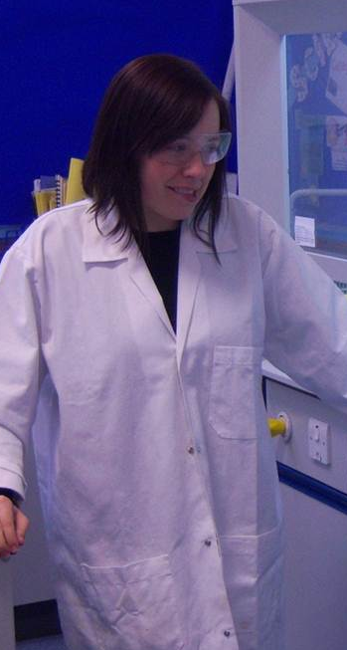
Advice from teachers:

- Always catch up on missed lessons by contacting your teacher for assignments and advice.
- Access the Bay House Learning course for extra study materials to help support completion of assignments, and for further reading and interesting websites.
- The more past paper questions you do the better you will do in your final exam.
- Visit the OCR website and use the correct specification (OCR Salters Board specification B) as a checklist for your learning.
- Don’t just read the textbooks and makes notes, try other techniques such as mind maps (especially helpful for calculations) and flash cards.
- Attend extra help sessions.
- Stay in contact with your teachers and communicate with them if you are taking time off, need help understanding a concept, need to catch up, or need a deadline extension.

Advice from students:

- Miss as few lessons as possible because when you miss even one lesson you have to catch up on so much learning.
- Work hard and make sure you know the concepts/reactions etc. before moving on.
- Get and use revision guides. The information is simplified and easy to understand.
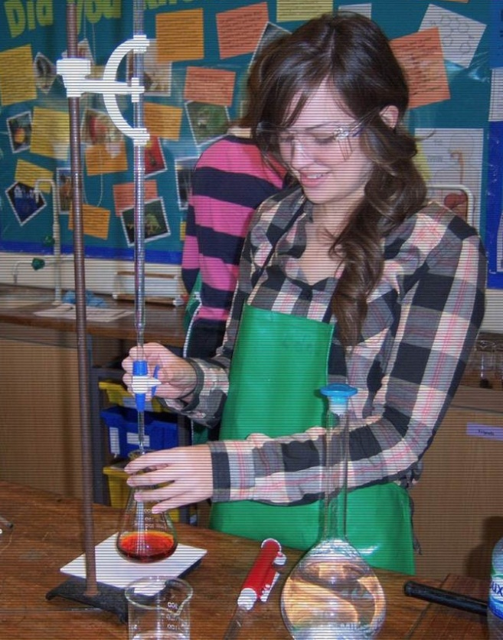
- Make detailed notes on the concepts covered in lessons (and keep them organised).
- Start revising early in the year!
- Read carefully (and re-read) the instructions for practical work.
- Take Chemistry, it’s brilliant. You’ll learn lots of new skills.
- Read around the subject / extra research.
- Go to Friday lunch club (help session).
- Revise a lot for end of topic tests.
- Complete lots of past paper questions.
- Complete all home study tasks.
- Ask for help as soon as you need it.
- Don’t panic! But don’t get complacent either.
- Look at the specification and base revision around this so all points are covered.
- Discuss chemistry questions with “clever” friends.

